**Dynamic Demographic Analyzer**

For MapInfo Pro v2021.1

August 2022

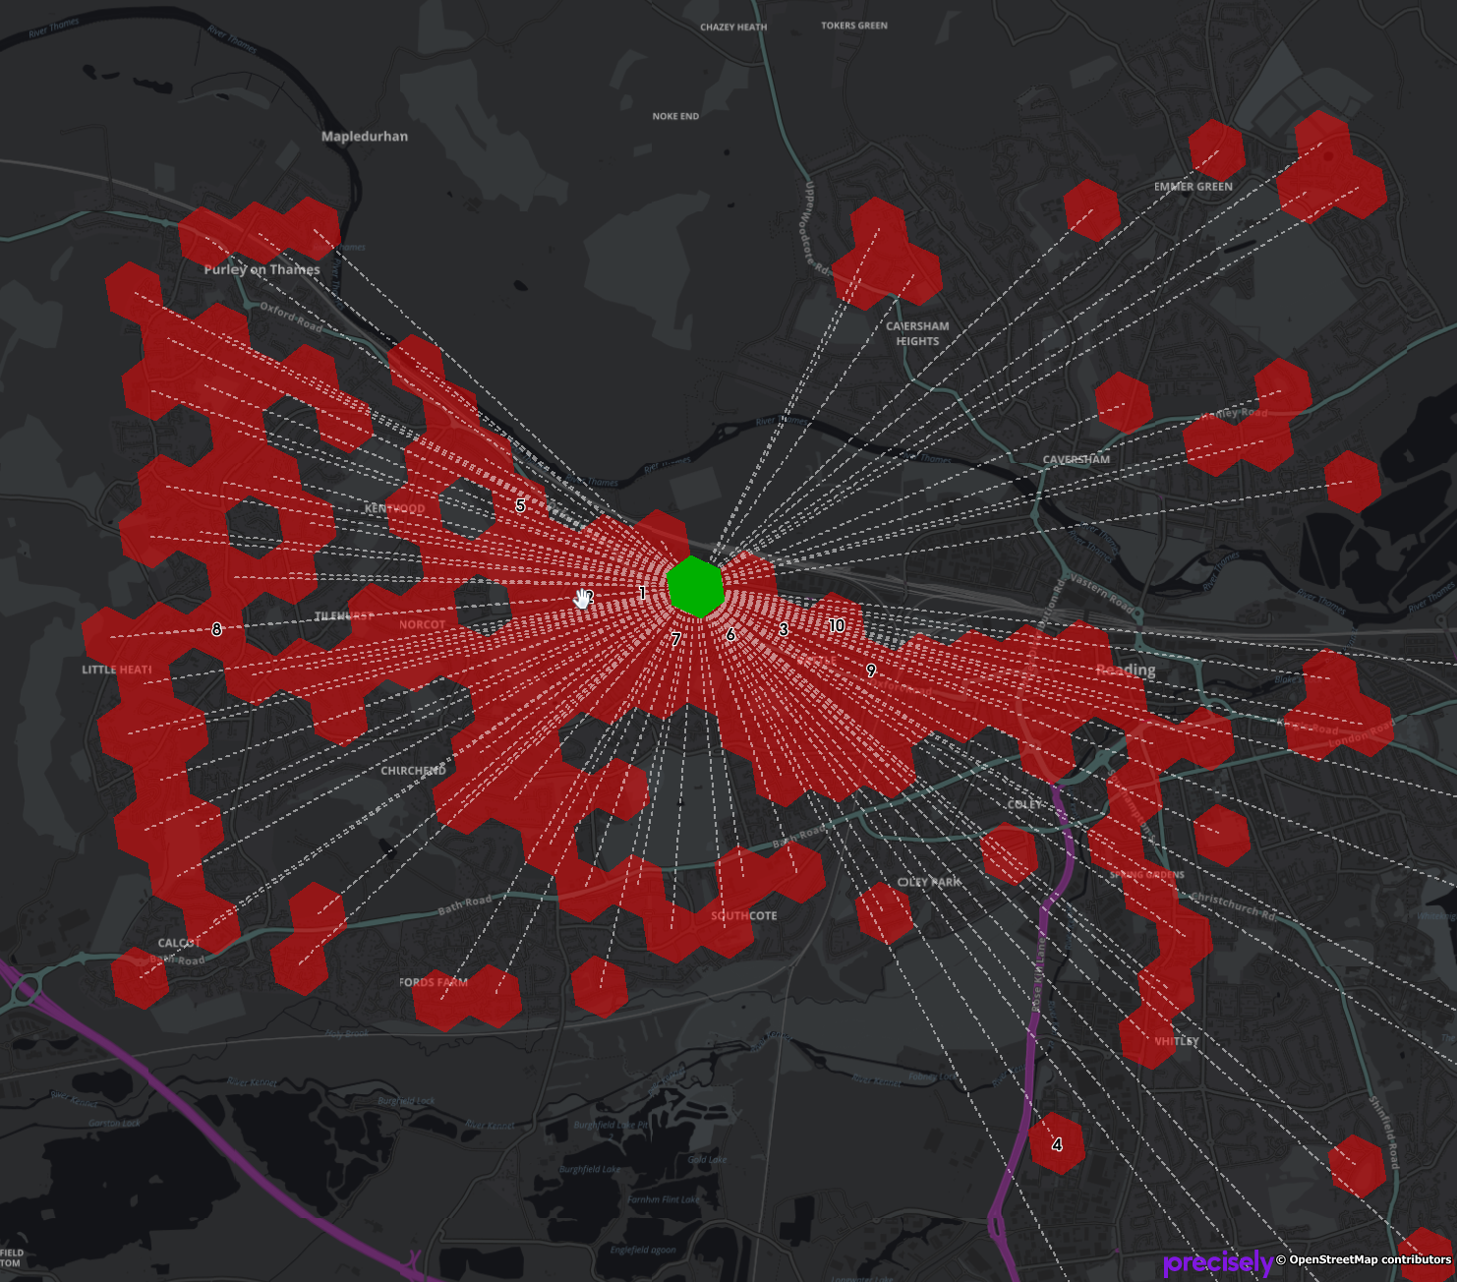

# Installation

Dynamic Demographic Analyzer is to be downloaded from the MapInfo Marketplace.

This distribution is automated so that you just click a button to get the add-in installed and loaded into MapInfo Pro.

If any updates to the tool gets published, you will see the small Notification symbol in the lower right corner of the MapInfo Pro window turn red. Double-click on the symbol to open the Notification window and from here access the updates from the MapInfo Marketplace where you easily can install the updates.

Please note that Dynamic Demographic Analyzer requires MapInfo Pro v2021 to work.

# Data Samples

Precisely Dynamic Demographic Data samples can be downloaded from the Precisely Data Experience:

<https://data.precisely.com/home>

You need to create an account to be able to find and download data samples.

# Loading Data

When you get the Dynamic Demographic Data, either as full datasets or as sample datasets, it is in the form of TXT files.

The Dynamic Demographic Analyzer can help you convert these text files into extended native MapInfo tables that can be used by the tool.

The data when unzipped comes in a specific folder structure that you need to maintain for the application to be able to work with the data.

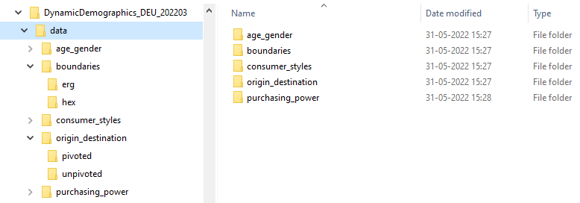

When the Dynamic Demographic Analyzer tool asks you to locate the folder with your data, it is the data folder shown above that you need to select.

The data folder contains the available data for the country you have data available for. For the sample datasets, you get a subset of the data for the country, typically data for a single city.

To load the data into a form for the Dynamic Demographic Analyzer can analyze, access the ***Data Loading…*** option from the context menu of the application in the ***Tools*** window.

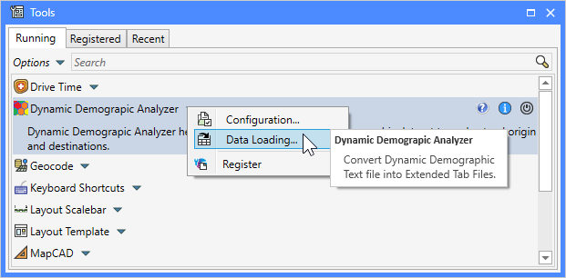

When you click this menu item, the dialog ***Load Data from TXT*** will appear. This dialog allows you to control what elements of the data you want to load into native MapInfo tables.

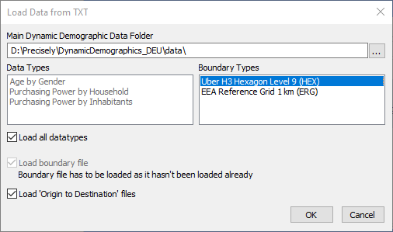

First, you need to point the ***Main Dynamic Demographic*** ***Data Folder*** to the folder described above containing the data.

This will prompt the dialog to load the available datatypes and boundary types and show these in the dialog. The data types and boundary type might differ from country to country.

You can either pick a single ***Data Type*** to load, or you can check the option ***Load all datatypes*** to load all the available data files into MapInfo tables.

Next, you will have to select what boundary type you want to load using the ***Boundary Types*** list. Above you can see that I have selected the Uber H3 hexagons. Also note that once you select a boundary type, the option ***Load boundary file*** might get checked and disabled. This will happened if the boundary file hasn’t already been loaded. If it hasn’t, it needs to get loaded as it will be used to enrich the data files with a boundary.

# Configuration

To access the ***Configuration*** dialog, click on ***Configuration…*** from the context menu of the application in the ***Tools*** window.

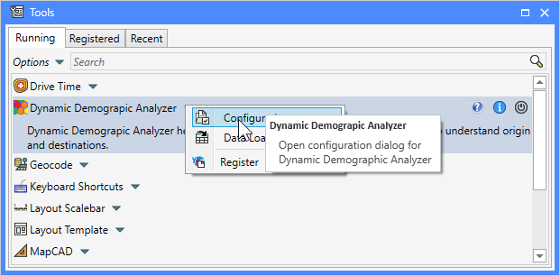

This will bring up the ***Configuration*** dialog.

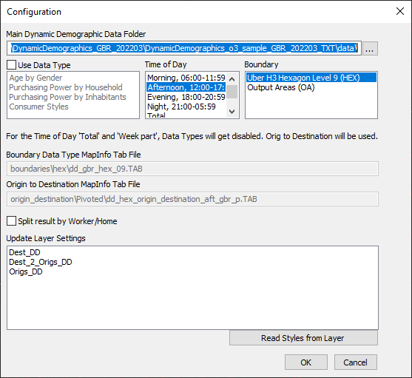

Here you can select the location of the ***Precisely Dynamic Demographic data folder***. It’s important that you have loaded the data into native tab files before using the ***Configuration*** dialog. Otherwise the application will not be able to locate the tables that are to be used.

After selecting the data folder, the dialog will load the available data types, the dayparts and the boundary types so that you can select from these.

Once you have selected from these 3 options, the dialog will show the name of the native tab files that will be used in your analysis.

If you uncheck the option ***Use Data Type***, the analysis will use the base boundary table and the origin to destination tables only. This is also the case if you select either ***Total*** or ***Week Part*** from the ***Time of Day*** list.

Do note that not all ***Data Types*** supports all ***Time of Day*** options. If the field for the ***Boundary MapInfo Tab File*** is empty, it means that the specified file cannot be found. You may have to select a different combination of input, or you may have to run the Data Loader again to get the data loaded.

If you have performed some analysis and have the resulting query tables open in the active map window, the list ***Update Layer Settings*** will show these resulting layers. You can now use the dialog to read and store the layer and label settings from these layers and use these settings for your next analysis.

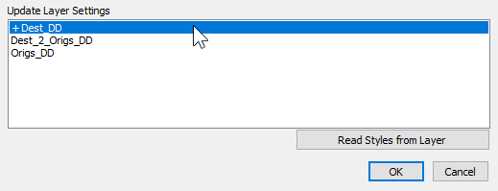

Select a layer from the list and click the ***Read Styles from Layer***, or simply double-click on the layer. This will add a “+” in front of the layer name indicating that the layer settings will be read from this layer when you click on the ***OK*** button.

# Analyzing Locations

From the ***Map*** tab, you can select one of the two buttons to analyze the Origin to Destination data.

Select the appropriate tool, and click in the map for the desired destination or origin location.



Note that the controls are disabled if you haven’t specified the location of the your Dynamic Demographic data and what data you want to use in you analysis. You can configure this through the ***Configuration*** dialog mentioned above.

The tool will now find the matching origins, or destinations, and also draw lines between the point where you clicked and these locations. 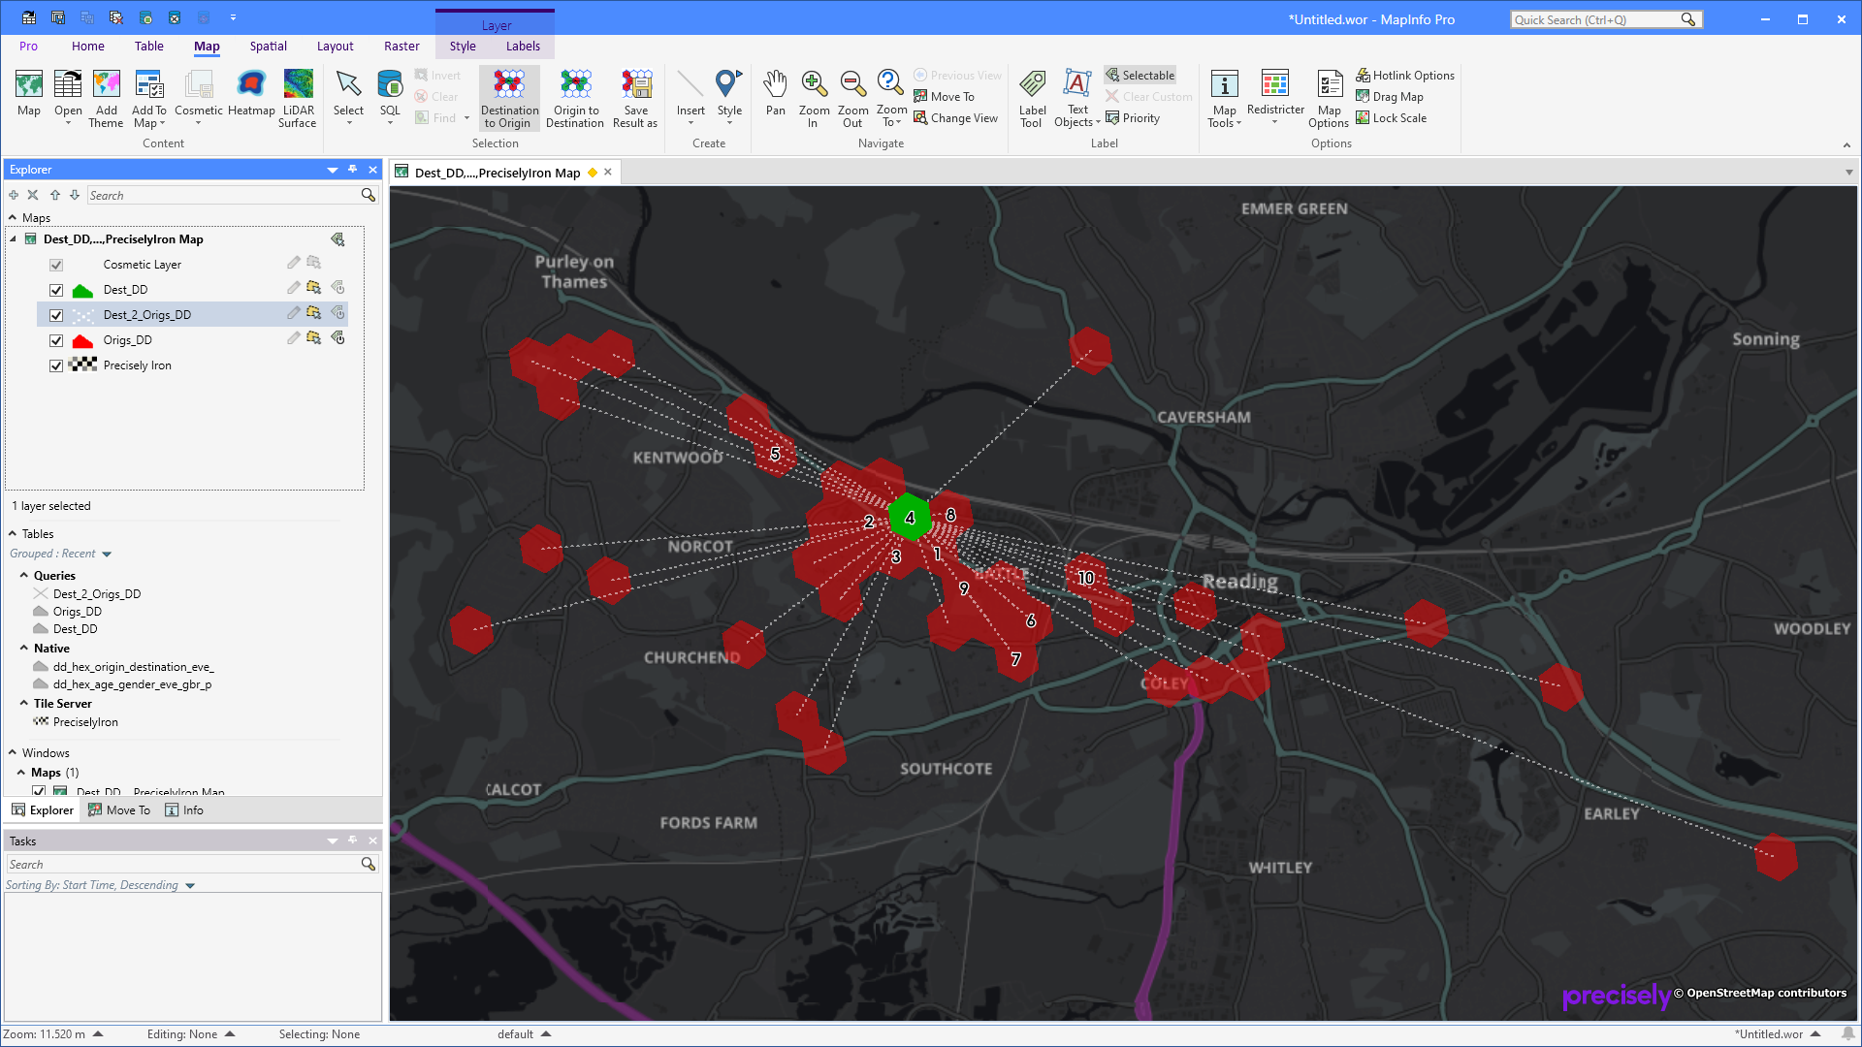

You can also select multiple polygons, for example hexagons, from the base boundary layer and run an analysis that creates an aggregated view of the origins for the selected destinations.

Please note that the tables created by the tool all are temporary tables. They are by default created in the current temporary folder and will not be saved to any workspace. In order to maintain an analysis result use the ***Save Results As*** option mentioned below.

# Saving Analysis Results

You can save your analysis results using the ***Save Results As*** from the ***Map*** tab. Note that the control is only enabled if you have an existing result from an analysis.

Click the control and specify the location where you want to store the result, and the name of your project. The given name will be used as part of the saved native tables.

Once the tables have been saved, the temporary query tables will be closed and the saved native tables will be opened in their place.

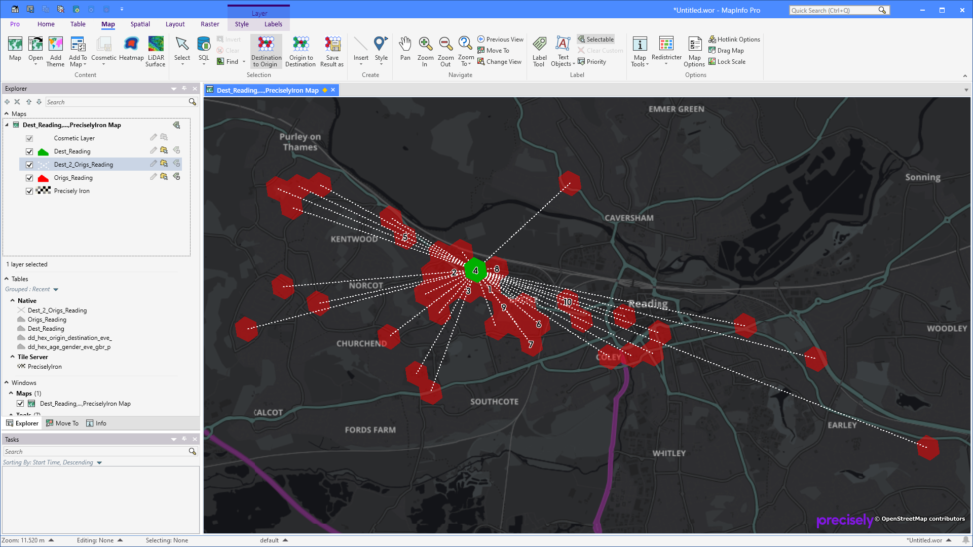

# Source code

The source code for this tool is shared via GitHub:

<https://github.com/PeterHorsbollMoller/mbDynamicDemograpicAnalyzer>

That means that you can grab the MapBasic source code and use this to improve the existing or build your own application to work with the Precisely Dynamic Demographic data set.

# Known Issues

Label expression is an issue as many columns also contain the daypart as part of their name. This makes is difficult to have one label expression for each of the 6 layer types (origin, destination, origins, destinations, origin to destinations and destination to origins). It almost seems that we need to store for each layer type and then split these by daypart, and maybe even per data type too.

# Improvement List

## Wish List

* Move all controls to a dedicated tab, ***DDAnalyzer***, and add controls for configuration and data loading too. Add some standard tools, such as Select, Pan, Zoom in and Zoom out to this tab too.
* Add a control that will clear the current result
* Add a control that will open the base boundary table into a map window
* For data loading, add an option to not overwrite existing tab files.
* Allow the user to see all the morning, afternoon, evening, and night origins for either weekday or weekend in one view: different colour for each day part or you could also colour the lines with an offset for each so you can see where they share the same destination
* Improve the way label settings, especially label expression is stored as the column names seems to differ across the different daypart tables.
* Change the way styling is handled to only store it for the main categories: origin, destination, origins, destinations, origin to destinations and destination to origins. Currently styling is also split by combined, work and home for each of the 6 layer types
* Data types should be moved to a configuration file so that it easily can be extended when necessary. Currently the list of data types is hardcoded in the application
* Boundary types should be moved to a configuration file so that it easily can be extended when necessary. Currently the list of boundary types is hardcoded in the application
* You should be able to select multiple Time of Day elements and when doing so, the tool should merge the columns from the selected Time of Day tables into the selected origin/destination. Alternatively, the user should be able to enrich a subset of boundaries with data from other data files, say they have used the morning file, and now they want to add the afternoon, evening and night values too, or even add values from other data types too. Need to keep count of the number of columns as the maximum is one thousand.
* Investigate if Excel could be used to creating graphs for the selected origin/destination.
* Compare two versions of the Dynamic Demographic dataset to show changes in attribute information.
* Batch process several selected polygons/areas and create analysis tables for each.

## Version 1.8.5

Lists in dialogs with base boundary types now only list boundary types with existing files. These can be txt or tab files depending on what process is.

Several issues have been fixed and improvements has been made to the data loading process: Fixed potential issue with seasonality having empty columns (converting Char to Float), added checks for support for and existence of 'origin to destination' files, and added checks for existence of 'seasonality' files.

Fixed issue where a file name wasn’t returned when multiple files where found.

Improved validation of Configuration dialog

The tool can now load Uber H3 Hex Level 11 boundary files which is part of Option 4.

The column type detection when loading data files has been improved. Earlier some columns got loaded as Integer instead of Float columns.

With the new Option 4, we have added support for handling boundaries that don't support Origin to Destination.

Data Loading now looks for Boundary Files, not just the folder in order to support Uber H3 Hex 11 which is found in same folder as Uber H3 Hex 9.

Data Loading now support preparing Seasonality for Time Series. The data will be transposed into a different structure better suited for Time Series visualization in MapInfo Pro.

## Version 1.7.0

Fixed a couple of issue where the tool crashed when no datatype was selected and with preselecting the current data type in the Configuration dialog

## Version 1.6.9

Fixed an error where numeric AREA_IDs where mistreating in the query

## Version 1.6.8

Save As control now gets disabled when no result exists.

Added a control to run an Origins to Destinations analysis based on selected boundaries. New icons for the controls that allows multiple boundaries as input.

For the single input analysis, the resulting line table now holds a column with the distance between the centroids of the two boundaries. The unit of this distance is based on the distance units from the System Settings dialog.

When saving your result into native tables, the tool now checks if tables already exist using the specified name.

Fixed an issue in the ***Configuration*** dialog when using OA boundaries and an issue where the selected folder doesn’t contain a boundary sub folder.

## Version 1.6.7

Fixed an issue that prevented the user from selecting Output Areas as boundary type.

## Version 1.6.6

We fixed an issue in queries where records without spatial object also where included. This made the application halt the execution.

The button that allows you to run an analysis on the selected records is now disabled until a selection has been made from the base boundary table.

We have changed the cursor for the two tools to a big crosshair. The earlier Arrow cursor caused confusing with the standard Select tool in MapInfo Pro.

## Version 1.6.5

Running an analysis on the full dataset has been optimized. The time used to query the tables has been cut by 90% or more. Where it earlier could take multiple minutes, it now takes less than 10 seconds.

Data loading has been improved. We had noticed that the character columns all were 2564 characters wide. The tool now minimizes the width of Char columns if they are 10 characters or more wider than necessary.

We have also added print statements to the data loading to give some feedback to user on data loading. You can now get an idea of the timing from the Message window.

## Version 1.6.0

The configuration dialog now allows you to not select a data type in your analysis. This can be useful if you are only looking at the flow of to/from destinations. This is also being used if you select either Total or Week part as your time of day.

A new analysis method was added by request. You can now select multiple polygons/areas and perform an aggregated analysis where the result shows all the origins to the selected polygons/areas. This is analysis does not return any data besides the number of destinations that each origin visits.

The analysis tables are now native tables stored in the temp folder, no longer query tables. The analysis tables are opened with persist set to off meaning the will not be saved to a workspace. In order to keep these tables, you will still have to use the option ***Save Results As***.

When splitting the result by Work and Home, the tool will now use the numeric columns PPT_H and PPT_W.

Fixed issues:

* Configuration dialog shows an error when no Data Type has been selected
* Data Loading dialog shows error when no Main Folder has been specified
* Consumer styles are now picked up and can be loaded into native tab files from text files

## Version 1.5.2

The Data Loading option now also converts the TOT (Total) and WPT (Week Part) files into MapInfo Native tables.

The Configuration dialog now allows you to select not only morning, afternoon, evening and night, but also Total and Week Part. These additional table split typical only exists for the Origin-to-Destination tables. This also means that you currently can’t select these if your boundary tables are split by time of day too. Unless the boundary table also holds these splits.

## Version 1.5.2

Fixed an issue with numeric values being used for the AREA_ID for some boundary types.

## Version 1.5.0

A new feature has been added to the tool. The feature Data Loading makes it possible to convert the delivered TXT files into native MapInfo tab files. The user can control which data files should be converted. This conversion also works for sample data and makes it possible to download the TXT files, convert these using the tool and then start using the Dynamic Demographic dataset in MapInfo Pro.



The Configuration dialog got another update. You can now also select the boundary type that you want to use. The list is automatically published using the boundary types from the ***boundaries*** folder.

Currently the tool supports these boundary type: HEX, ERG, SA1 and OA.

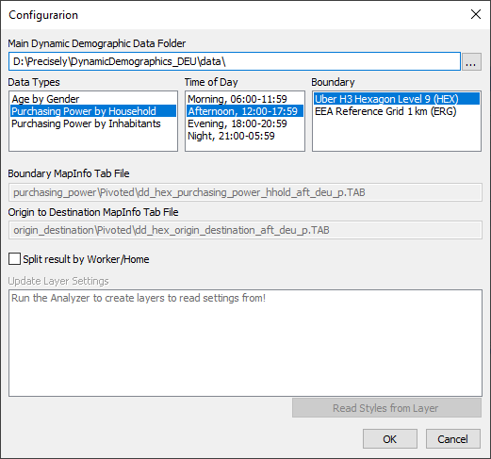

The option to save an analysis into a set of static tables has been improved. You now specify a name for your project which gives you the option to open up multiple analysis results at the same time as the name of the project will be used in the name of the analysis tables. “*Destination_DD”* will be renamed to “*Destination_LondonEast*” as an example.

The analysis tables have been shortened. “*Destination_DD*” will now be “*Dest_DD*” and “*Origins_DD*” will be “*Origs_DD*”. This makes it possible for longer project names when you save your analysis result.

If an error occurs when applying the label expression to the analysis layer, the application will now default to the first column in the layer.

The application now comes with documentation in the form of this document.

## Version 1.4.0

I know there has been a few issues with the latest version and I have tried to address these in this new release, v1.4.0. Some of the issues occur because the user pick the wrong input tables. I have tried to address this by changing the Configuration dialog to what you see below.

You no longer select the actual input tables, you select the Main data folder holding the different sub data folder. The application will then find and show you possible data types you have available. Below, you can see the data types for Australia which are different to those in England and Germany.

After selecting the Main data folder, the Data Types and Time of Day lists get published.

You can now select the data and time of day from these lists.

This is enough information for the application to pick the actual tables to use.

If you have multiple polygon types, hex and boundaries, for now you will have to separate these at the Main Data Folder level.

We can consider extending the tool to let you choose between multiple boundary types too.

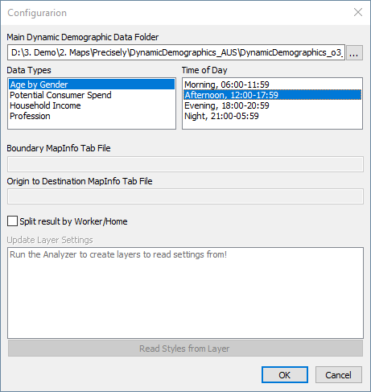

For now, the application will only work with Pivoted datasets. If it turns out to be, we can extent the application to allow you to select between Pivoted and Unpivoted.

The application now also checks for the AREA_ID column, it that isn’t found it will use DEST_AREA_ID instead. This was reported by the Australian team so I’m not sure if the same problem might have existed for UK and DE.

It spits out all sorts of debug messages to the Message window. To turn of these, delete the file DynamicDemograpicAnalyzer.dbg in the application folder.

## Version 1.3.1

Currently, the tool runs in debug mode. This means that I print a lot of debug information to the Message window.

You can look at this to see what queries I run to find the origins and destinations. You can also find this in this file in the application folder: DynamicDemograpicAnalyzer.dbg

Destination to Origin query:

Select * From dd_hex_purchasing_power_househ, dd_hex_origin_destination_aft_

Where dd_hex_purchasing_power_househ.Area_ID = dd_hex_origin_destination_aft_.Origin_Area_ID

And dd_hex_origin_destination_aft_.Origin_Area_Type = "Work"

And dd_hex_origin_destination_aft_.Dest_Area_ID = "89195d2b3c3ffff"

And OBJ

Into Origins_Work_DD NoSelect

Origin to Destination query:

Select * From dd_hex_purchasing_power_househ, dd_hex_origin_destination_aft_

Where dd_hex_purchasing_power_househ.Area_ID = dd_hex_origin_destination_aft_.Dest_Area_ID

And dd_hex_origin_destination_aft_.Origin_Area_Type = "Work"

And dd_hex_origin_destination_aft_.Origin_Area_ID = "89195d2b3c3ffff"

And OBJ

Into Destinations_Work_DD NoSelect

You can now control the display of the resulting query tables in the map yourself. Configure them to look as you want and then use the new Configure dialog to read and store the layer and label settings for the layers.

Checkbox in the Configuration dialog to control the Split by Worker/Home option

Option to save analysis result into static tables. This will save the analysis report query tables into native tab files in a chosen location, close the queries and open the native tab files in their place.

Below you can see the new button for Saving the Analysis Result into native tab files next to the two analysis tool buttons. And notice the Configuration option on the context menu of the tool in the Tools window

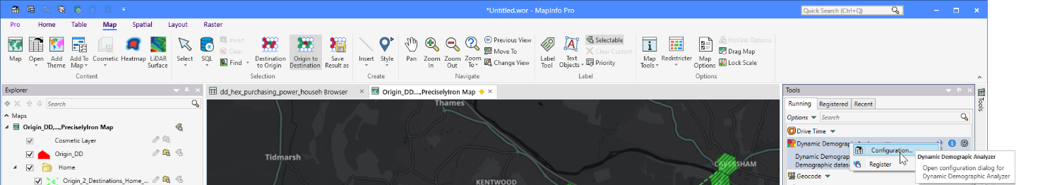

An example of how the result now can be represented with custom styles for the individual query results and support for labels, too.

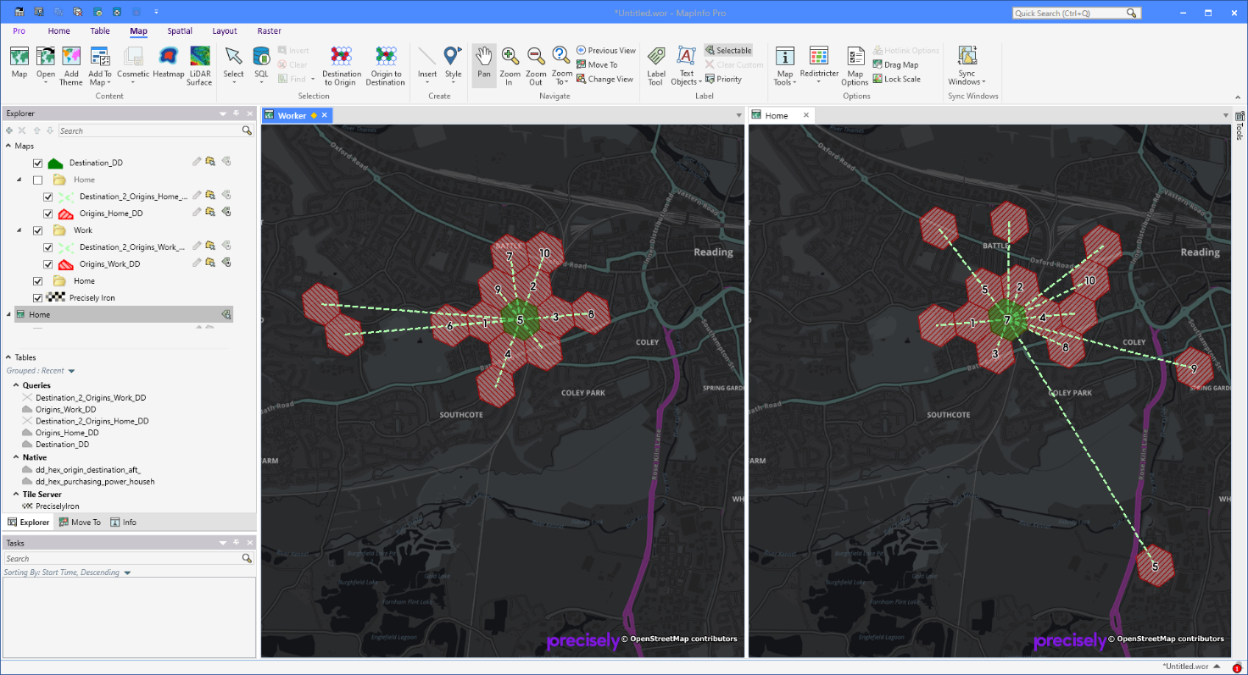

I have started gathering all the configuration in a single dialog. This is now also the place where you set the tables to use: The boundary table and the origin-to-destination table.

You can here also turn on/off the option to split the result by Home/Worker.

And finally, I have here added the option for you to read styles from the open layers and store these settings. Once read and stored, the application will use these settings when showing the result in a map moving forward.

In the dialog below, you can also see the result tables/queries for Destination to Origin. That’s because that’s the analysis I used before opening the dialog. If you have used the Origin to Destination analysis instead, it will be these tables you see in the dialog. If you haven’t done any analysis, the list of tables will be empty.

You can select a layer and use the button Read Styles from Layer or just double-click on the layer. When you have set a layer to be updated with layer settings, a “+” I shown in front of the layer in the list.

Note that reading the layer settings also read the label settings and can show labels for the polygons as you can see in the maps above.

I used an expression to only label the top 10 ranked hexagons (IIf(rank_d < 11, rank_d, ""))

